ASIMUT Student User Room Bookings Guide
Go directly to Asimut http://www.rncm.ac.uk/asimut or via Moodle, from a web browser, a smartphone or click the “A” icon on the desktop when using a College PC and login using your RNCM username /password.

Your schedule for the week will also be displayed here.
Make a booking
- Select a date from the calendar
Either input the room number /name in the search box or select the group of rooms you are looking to find a space in from the list of location groups, all rooms are grouped by location
- Once you select the group or specific room you will be showed the availability of the space.
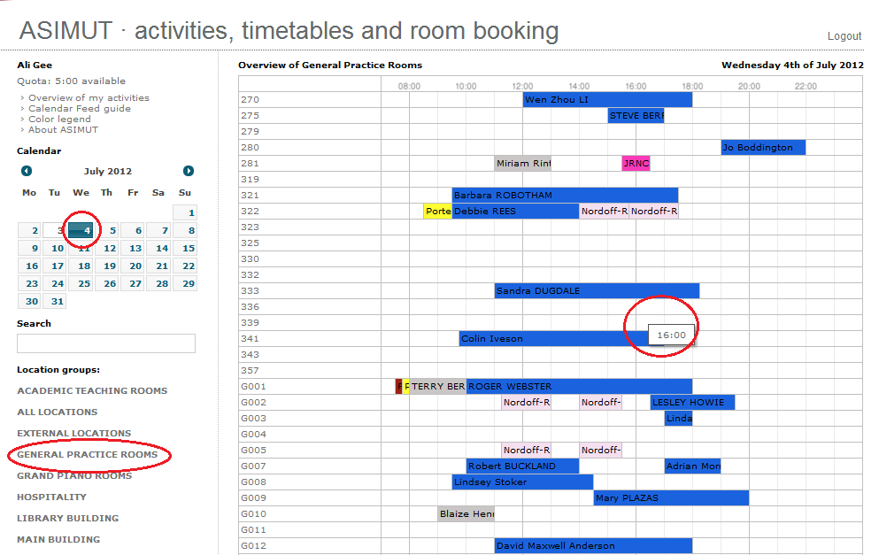
- Click in a free space, a new window will open
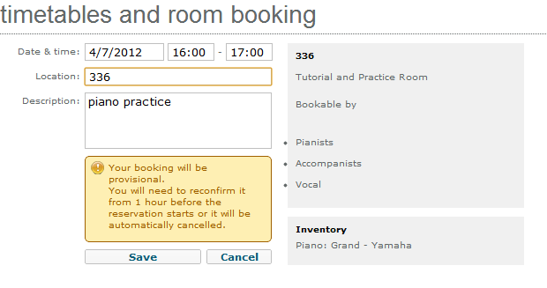
- If you are authorized to book that particular room – see the detail on the right panel. You can alter the time up to 2 hours. You could also change the location from this screen too. Or just hit save to make the provisional booking. There will be a warning if you try to book over 2 hours or are not authorized to book that room.
- The provisional booking will now display in your agenda
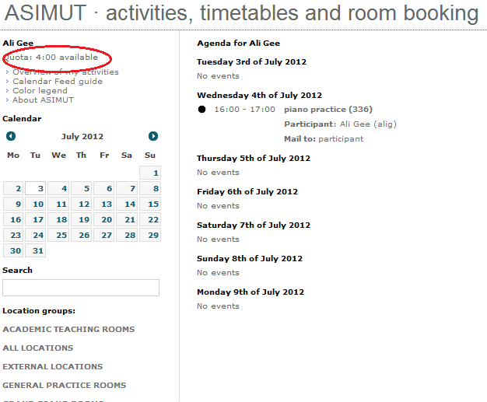

- You will also notice that the hour has been subtracted from your quota
- You can still cancel the booking any time up until the commencement time to have your quota reimbursed, if you do not cancel prior to this your quota will not be reimbursed until the booking as elapsed.
- To cancel just click on the booking name (piano practice) to open the booking window
- Click on the Cancel Booking button

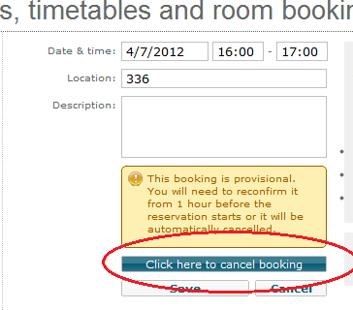
- To make a booking, and search for personal schedules you need to swipe your RNCM ID Card.

Reconfirm or Cancel Booking
- To reconfirm your bookings go to one of the many designated touch screens around the college
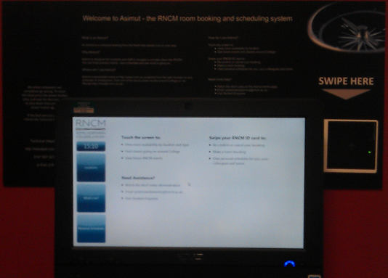
- Swipe your RNCM ID on the card reader, this acts as your authentication
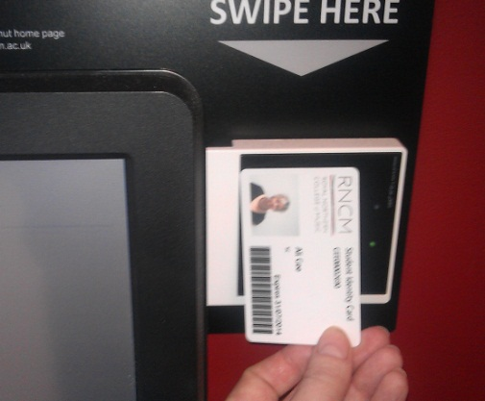
- You cannot re-confirm your booking without your RNCM ID Card.
- The screen will display your bookings for the day and will allow you to reconfirm those commencing within the next 4 hours by touching tick. Or to cancel touch the cross. Once you have reconfirmed your bookings you may still cancel them by logging into the system.
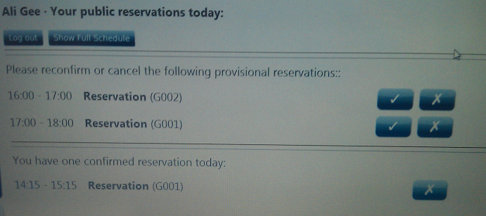

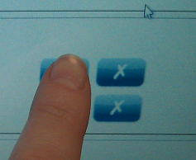
- From the touch screens you can also make a bookings, search for tutors and peers schedules and see what events and classes are happening today around the college.

- To reduce queues at peak times, avoid using the touch screens to make bookings. This can be done from any computer or smart phone.

Touch Screen Locations

2 in reception at the bottom of the stairs
1 outside the green room in the refectory
1st floor library corridor entrance
2nd floor library corridor entrance
Ground floor oxford road wing opposite the lift
Ground floor oxford road wing opposite room 14
3rd floor main building next to room 331
3rd floor main building next to room 352
3rd floor main building outside counselling suite
2nd floor main building balcony overlooking concourse

