Procedures for “On the Day” Booking Amendments & Late Arrivals
- Amending an “On the Day” Booking
In some cases, students cancel on the day at the last minute, therefore reducing the number of hours needed in a room. You are able to amend your reservation on the day to start later or finish earlier without having to go to the touch screen in College, by simply logging onto http://www.rncm.ac.uk/asimut from any web browser and editing that reservation. This booking will still be provisional and you will still need to confirm at a touch screen on your arrival to College. This will save the need to speak to an administrator.

Step 1 – Select the reservation you wish to edit by clicking on the link
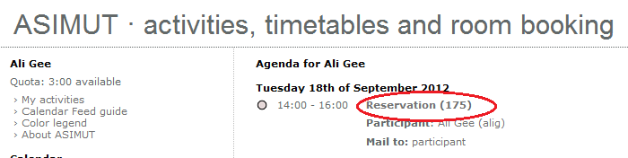

Step 2 – Click in the start / end time to make the amendment, select the revised time and click save
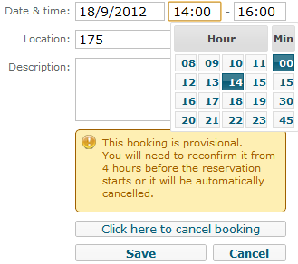
- Late Arrivals
If you are delayed in getting to College for your first teaching hour and are certain you will not make the 10 past the hour deadline to confirm your room bookings at the terminal you have the following options:
During office hours of 9am-4pm Monday – Friday
- Call Systems and Planning 0161 907 5200
- Send a text to 81025 You must prefix your text message with the word ASIMUT, ensure you include your name and the time of your booking
Outside office hours before 9am and after 4pm Monday – Friday and during weekends
- Call Reception 0161 907 5300
- Send a text to 81025 You must prefix your text message with the word ASIMUT, ensure you include your name and the time of your booking

The number of late arrivals will be monitored and any patterns of concern will be reported to the Acting Principal and Head of School.

